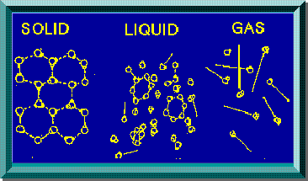

Year 11 Chemistry
AECHE
Unit 2
Kinetic Theory and Gases
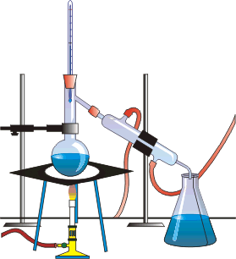

Data from chromatography techniques including thin layer (TLC), gas (GC) and high-performance liquid chromatography (HPLC), can be used to determine the composition and purity of substances; the separation of the components is caused by the variation in strength of the interactions between atoms, molecules or ions in the mobile and stationary phases.

Chromatography

- Chromatography is a method for separating and identifying the components of a mixture.

- All types of chromatography consist of a stationary phase (solid or solid covered in liquid) with a mobile phase (liquid solvent or a gas) moving over it.

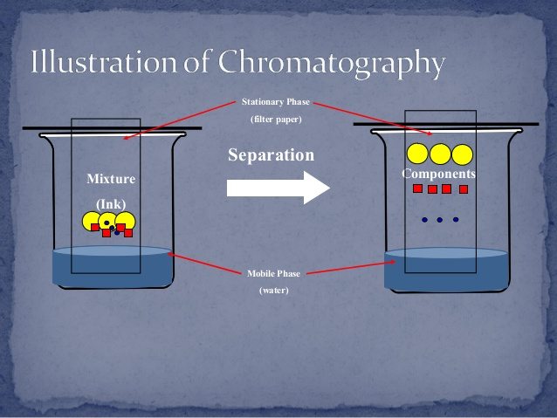

- When the mixture (analyte) is added, components of the mixture will show a preference to dissolve in the mobile phase or adsorb (stick) to the stationary phase to different extents.

- Substances that dissolve in the mobile phase will be carried with it, moving them through the chromatography medium.
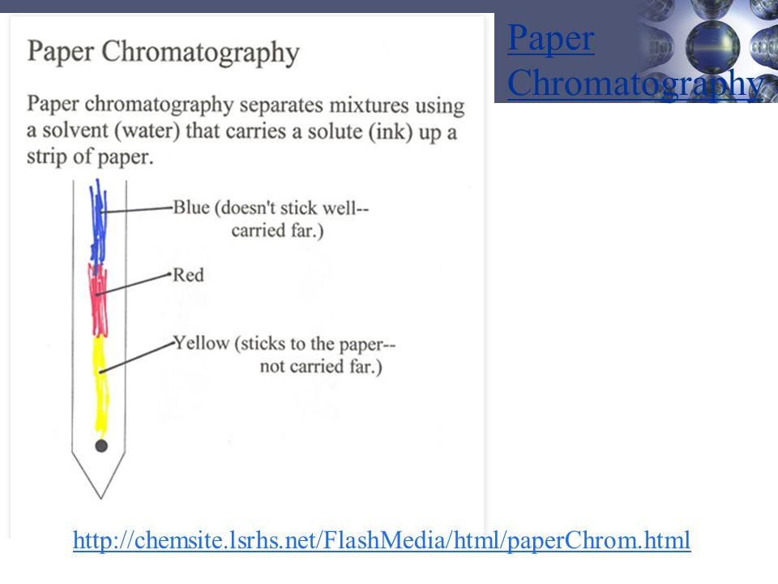
- The components of the mixture become separated as substances that spend more time dissolved in the mobile phase move further along the chromatography medium, becoming separated from the components that spend more time adsorbed to the stationary phase.

- The separation is determined by the intermolecular forces between the substances, as this determines which phase they will best interact with.

- Chromatography commonly uses a polar stationary phase and a non-polar mobile phase.
- Components of a mixture are separated by polarity, with non-polar substances travelling the furthest.
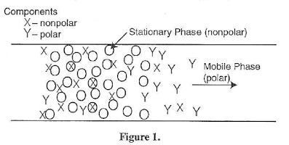
- Some chromatography works the other way around.

NC 6.9 p289-90 EC 19.1 p164
Types of chromatography

Paper Chromatography

- Stationary phase: Strip of chromatography paper (polar)
- Mobile phase: Solvent (non-polar)

- How it works: The mixture is spotted onto the paper. The solvent travels up the paper by capillary action, carrying the components of the mixture with them.
Small sample of dye (1) is placed on pencil line (2) at the base of the chromatography paper. The chosen solvent (3) soaks through the strip by capillary action. Various components of the dye (4), (5), (6) begin to separate according to their polarity.
Solvent (7) advances quicker than any component.
EC 19.2 p 164
Column Chromatography

- Stationary phase: Small beads of alumina or silica in a glass column (polar).
- Mobile phase: Solvent (non-polar).

- How it works: The mixture is placed at the top of the column. The solvent flows downwards through the column bringing the components of the mixture with it. Non-polar substances travel further.
A glass tube (1) is packed with alumina or silica gel (stationary phase). It is then filled with a solvent (mobile phase). A small sample of solution containing the mixture (2) is placed at the top. The tap at the base (3) is opened allowing the mixture to flow through. Fresh solvent (4) is continually added. Over time, components (5) and (6) begin to separate depending on their tendency to stay dissolved versus their tendency to adsorb onto the gel.

EC 19.3 p165
Thin Layer Chromatography (TLC)

- Stationary phase: Glass plate coated in alumina or silica (polar).
- Mobile phase: Solvent (non-polar).

- How it works: The mixture is spotted onto the plate. The solvent travels up the plate by capillary action, carrying the components of the mixture with them. Non-polar substances travel further.

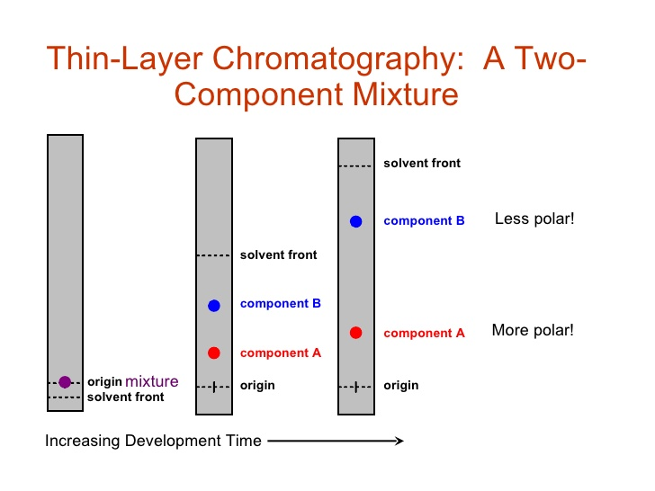
NC 6.9 p291-3 EC 19.4 p165-6

Gas Chromatography (GC)

- Stationary phase: High boiling point non-volatile liquid adsorbed onto solid particles within a stainless steel column
- Mobile phase: Chemically inert carrier gas (usually helium).

- How it works: The mixture is added to the carrier gas stream and vapourised. More volatile analytes have a greater tendency to remain in the mobile phase and move through the column quicker (have lower retention time).
A sample is injected into injection port (A). Vaporised sample is carried by carrier gas through the chromatography column (B). Various analytes travel at different rates through the column and become separated. A detector (C) signals the presence of the analytes as they emerge. The signal is processed and displayed as an intensity versus retention time chromatagraph.

NC 6.9 p293-4
EC 19.6 p167
High Performance Liquid Chromatography (HPLC)

- Stationary phase: Tightly packed fine solid particles (eg silica) within a column.
- Mobile phase: Liquid solvent (in normal phase HPLC the mobile phase is non-polar, but in reverse phase HPLC a polar mobile phase and non-polar stationary phase are used).

- How it works: The mixture is injected into a sample injection loop and carried through the column by the solvent. Analytes with a similar polarity to the solvent have a lower retention time.
Sample is injected through an injection loop (A) into a high pressure column of solvent.. The sample passes through the chromatography column (B) where various analytes travel at different rates and become separated. A detector (C) signals the presence of analytes as they emerge. The signal is processed and displayed as a chromatograph showing retention times, peak heights and area.

NC 6.9 p294-5
EC 19.8, 19.9 p168-9

Advantages/Disadvantages of Different Types of Chromatography

 | TLC | GC | HPLC
Qualitative or Qualitative | Qualitative | Qualitative & Quantitative | Qualitative & Quantitative
Detection type | Can be non-specific (eg iodine vapour) or specific (eg antibody related methods) | Flame ionisation detector (gives retention time) or mass spectrometer (can identify analyte) | UV detector (UV absorbance can be used to calculate concentration)
Uses | Simple/cheap screening tests for drugs (require GC confirmation), separating dyes etc. | Environmental monitoring, forensic testing, drug testing etc. | Analysis of mixtures containing larger molecules (fats, oils, amino acids etc) in research or food & beverage industry
Limitations | Not quantitative, prone to false positives | Run at temperatures up to 250 °C, which causes some substances (M > 300 gmol⁻¹) to decompose | $$$  Volatile substances are better separated by GC

Calculate retention factors for components in TLC and paper chromatography.

Analyse gas chromatograms to determine polarity and relative concentrations of components.

Retention Factor R_{f}

Different solvents will change the separation pattern of the mixture.

The retention factor, R_{f} value, of a pigment is a statistic used to identify how a pigment behaves.

Each pigment has it’s own specific R_{f} (for the same solvent, same time).

Retention factor (R_{f}) is defined as the ratio of the distance travelled by the centre of a spot, to the distance travelled by the solvent front

$$R_{f}= \frac{migration distance of the substance}{migration distance of the solvent front}$$

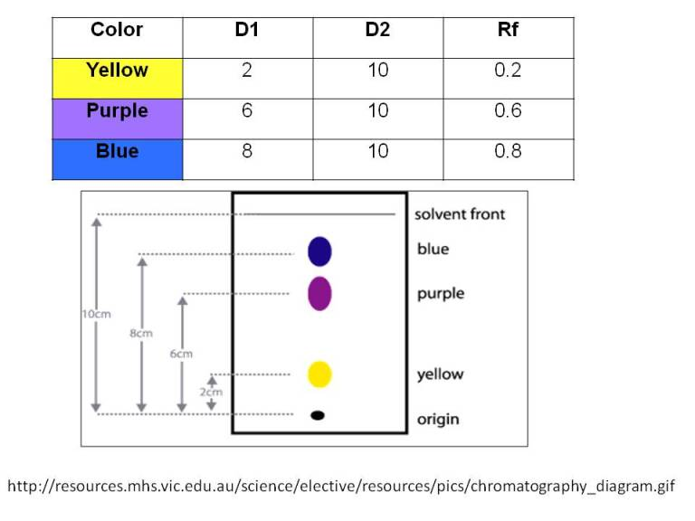



EC 19.7 p167, 19.10 p169-70

- Complete the following table:
Type of Chromatography | Stationary Phase  Give the state and an example | Mobile Phase  Give the state and an example | Separation method
Paper
TLC
Column
HPLC
Gas

- What is the main difference between TLC and paper chromatography?

- What does HPLC stand for?

- What does the distance travelled by the dots on the plate tell you about the polarity of the substances? What does a dot that doesn’t move very far tell you? What about one that moves the full length of the plate?

- What does R_{f} stand for?

- How is it calculated?

- How is the R_{f} of a compound related to its polarity?

- What does the term ‘volatile’ mean?

- What are the two main factors that separate components of a mixture in a gas chromatography instrument? Explain how they are separating the different components.

- Why is GC coupled with other analytical techniques?

NC QS 6.6 p296-8
The behaviour of an ideal gas, including the qualitative relationships between pressure, temperature and volume, can be explained using the Kinetic Theory

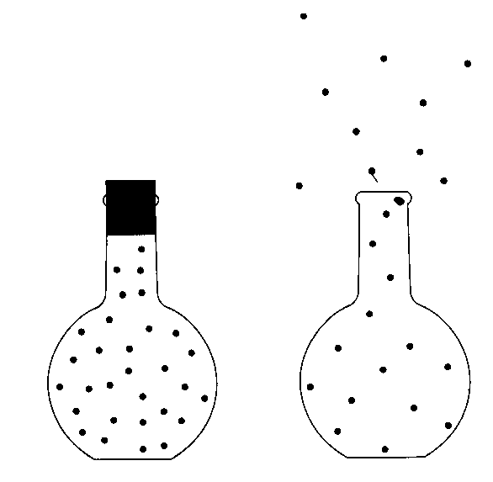
The Kinetic Theory of Gases
- Properties of gases:
- Can be compressed easily
- Can be liquefied, even solidified
- Occupy the whole volume of their containers
All these phenomena and more can be explained by the kinetic theory of gases – all gases are made up of particles of matter in a state of constant motion.

- Assumptions on which the kinetic theory of gases is based includes:
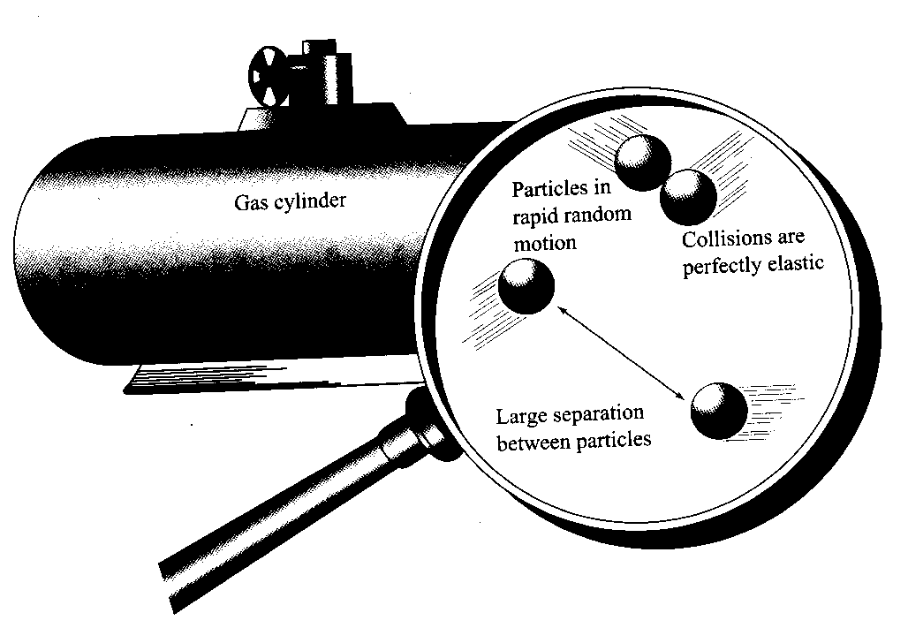
- Gases consist of tiny particles called molecules, except for the noble gases – these consist of atoms.
- The molecules move in rapid, random, straight-line motion – results in collision with each other and the sides of the container.
- Average distance between the molecules of a gas is very large compared to the size of each gas molecule.
- The molecules exert negligible attractive or repulsive force on one another (intermolecular forces).
- All collision of gas molecules is perfectly elastic, which means there is no net energy loss during the collisions.
- Average kinetic energy of the molecules increases with temperature, meaning temperature is a measure of the average kinetic energy of the molecules.

Gases that obey all the assumptions of the theory are known as ideal gases.

Energy and States of Matter
- The energy in matter can be stored as:
- Kinetic energy – energy due to the motion of the particles.
- Potential energy – energy due to position (how far apart the particles are).

Potential Energy
- Solid – particles are close together; low potential energy.
- Gases – particles are much further apart; high potential energy.
- Liquids – particles are further apart than those in a solid but closer than a gas; higher potential energy than solids but less than a gas.
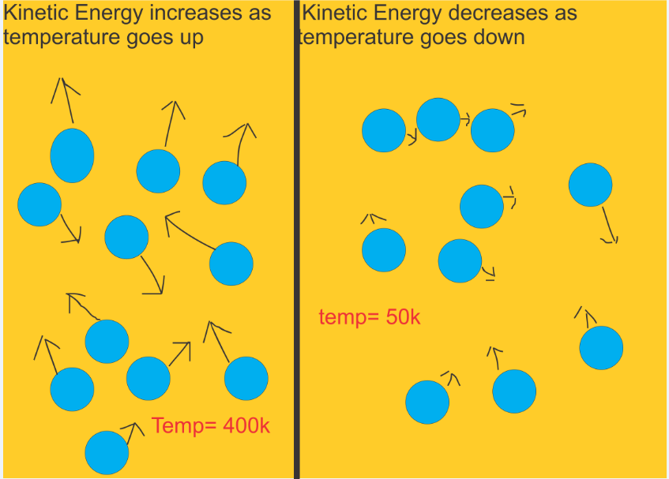
- The potential energy of particles increases when they go from solid to liquid to gas: energy has been supplied to overcome the attractive intermolecular forces between the particles.

Kinetic Energy
- The kinetic energy of substance increases by increasing the temperature, this increases the velocities (vibrations) of the particles and hence the kinetic energy.
- Heat – flow of energy from a hotter object to a cooler object until an equilibrium is reached.
- Temperature – the measure of the average kinetic energy of the particles in a substance.

- The heat gained by a substance is a measure of increases in the total energy (kinetic + potential).
- The molecules of a gas sample always have a range of kinetic energies at any given temperature.
- The measure of the average value of the kinetic energy is the temperature.
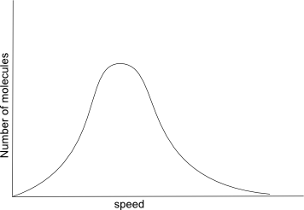
Average
Large number of molecules with intermediates velocities.
Small number of molecules with high velocities.
Small number of molecules with low velocities.
(Temperature)

- As the temperature increases, the velocity and the average kinetic energy of the particles increases. This causes the graph to move to the right.
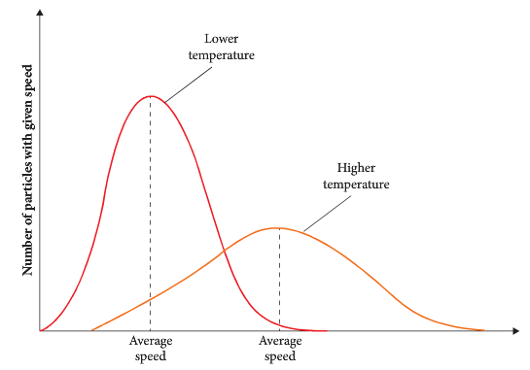

- The average kinetic energy of two gases at the same temperature is the same. As kinetic energy, E_{k} = ½ mv². Gases of lower molar mass move faster than gases of a higher molar mass so E_{k} same.
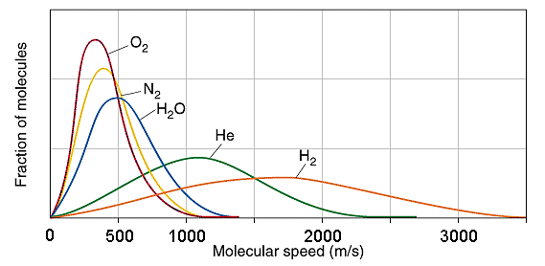
Heavier gas

Lighter gas

- Temperature change is due to a change in average kinetic energy only.
- A change in state is due to a change in potential energy of the particles.
NC 8.2 p346-49 QS 8.2 p348-9 EC 1.2, 1.3, 1.4, 1.5, 1.6 p164-5
PROBLEM SET :
- Explain why liquids and gases are both known as fluids.

- Use the kinetic theory to describe the different arrangements of particles in solids and liquids and explain the characteristic properties which result.

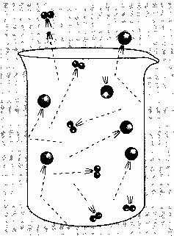
- A helium atom has twice the mass of a hydrogen molecule.
Which has the greatest E_{K} if:
- they are both moving at 500 ms⁻¹?
- the helium slows to 250 ms⁻¹?

- The kinetic theory is used to explain the physical properties of gases:
- Diffusion of gases – such as if perfume is spilt, it can be smelt throughout the room. Due to constant motion of the particles – gases will continue to move in all directions until stopped by the walls of a container.
- The compressibility of gases - large spacing between the molecules compared with the size of each molecule. Most of the volume occupied by a gas is empty space.
- Gases spread to fill a container – because the intermolecular forces are negligible.
- Gases exert pressure – because the particles move rapidly and collide with the surface of any container.
- Gases have low density - most of the volume occupied by a gas is empty space.

PROBLEM SET:
- How does the kinetic theory explain the fact that the pressure of a gas in a sealed container remains constant indefinitely, provided the volume and temperature remain constant?

- Why are gases easily compressed?

- Explain why gases spread to occupy the available space.

- The molecules of real gases:
- Always have an attraction for one another – at lower pressures or at higher temperatures the attractive forces are outweighed by the great distances between the molecules or by the increases in kinetic energy of the particles.
- When temperature drops or the pressure increases, or both, molecules begin to attract one another.

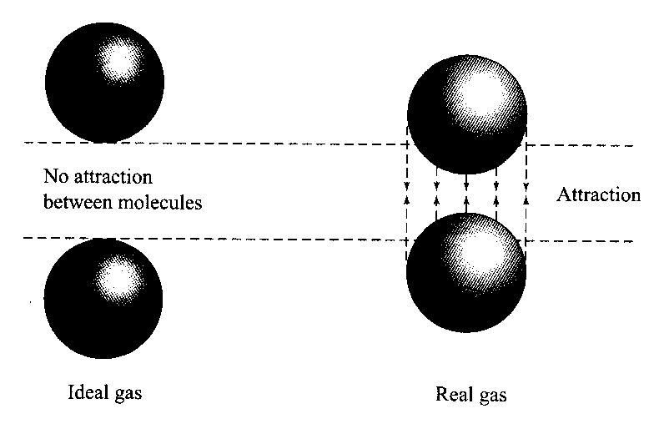
- These attractive forces are weak, but they have enough strength to limit the movement of the molecules and they form what we call a liquid state. When the temperature drops further or pressure increases, the motion of the molecules slows even further and the attractive forces between them become much stronger.

- At some particular point of temperature and pressure, the molecules and clusters of molecules are held in definite position in the solid state.

- The movement of particles when they are in the gaseous state are widely spaced and exhibit random straight-lined movement.
- Intermolecular forces between gas particles are so small, they can be ignored.

Crash Course Chemistry #14 https://www.youtube.com/watch?v=GIPrsWuSkQc

Gas Laws

- Standard conditions for working with gases are:
STP (Standard temperature and pressure): t = O °C (T = 273.15 K) and P = 100 kPa
SLC (Standard laboratory conditions): t = 25 °C (T = 298.15 K) and P = 100 kPa
Crash Course Chemistry #12 https://www.youtube.com/watch?v=BxUS1K7xu30

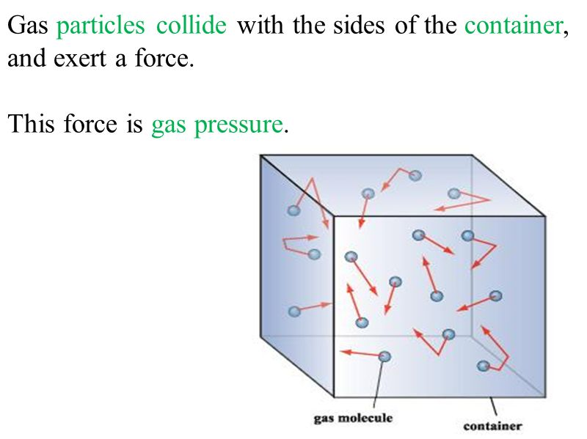
NC 8.3 p349
Boyle’s Law
- Gas pressure is related to the collisions of gas molecules with the walls of the container.
- Gas pressure is determined by:
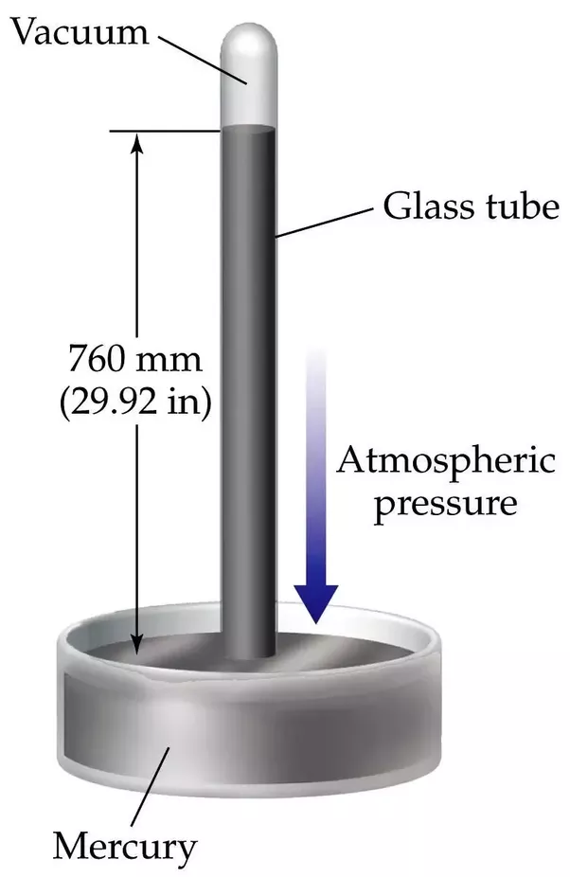
Particle momentum and Frequency of collisions of the gas molecules with walls of the container.
- The units of pressure include: 1 atmosphere (atm) = 760 mmHg = 101.3 kPa
- The volume of a gas decreases when the pressure on it is increased.
- The volume of a gas increases when the pressure on it is decreased.

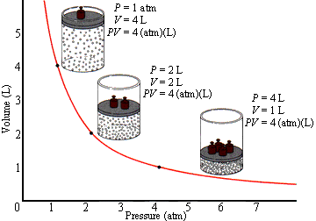
- Boyle’s Law:
If the temperature of a gas is kept constant,
the volume of a given mass of gas is
inversely proportional to the applied
pressure.

This law can be expressed mathematically as:

The larger the pressure, the smaller the volume.

- If a particular sample of gas is kept at a constant temperature while the pressure and volume are altered, the following relationship applies:
where: P₁ = initial pressure P₂ = final pressure
P₁V₁ = P₂V₂
V₁ = initial volume V₂ = final volume

- A reduction in the volume of a gas results in a greater number of molecules per unit volume.
- This causes the molecules to collide more frequently with the walls of the container resulting in an increase in the pressure.

Example:
Air in a 50 mL container has a pressure of 125.5 kPa. Calculate the pressure inside the balloon if the container’s volume change to 340 mL, assuming there is no temperature rise.

P₁ = 125.5 kPa P₁V₁ = P₂V₂
V₁ = 50 mL 125.5 x 50 = P₂ x 340
P₂ = ? P₂ = 125.5 x 50
V₂ = 340 mL 340
P₂ = 18.5 kPa
NC 8.3 p349-51
Charles’s Law
  - A rise in temperature increases the average kinetic energy of gas molecules. Molecules move faster; hitting harder and bombarding the container’s walls more frequently, thus increasing the pressure.
  - If the volume of a gas is constant, pressure increases with increasing temperature.
  - If the pressure is constant, the volume increases with a rise in temperature.
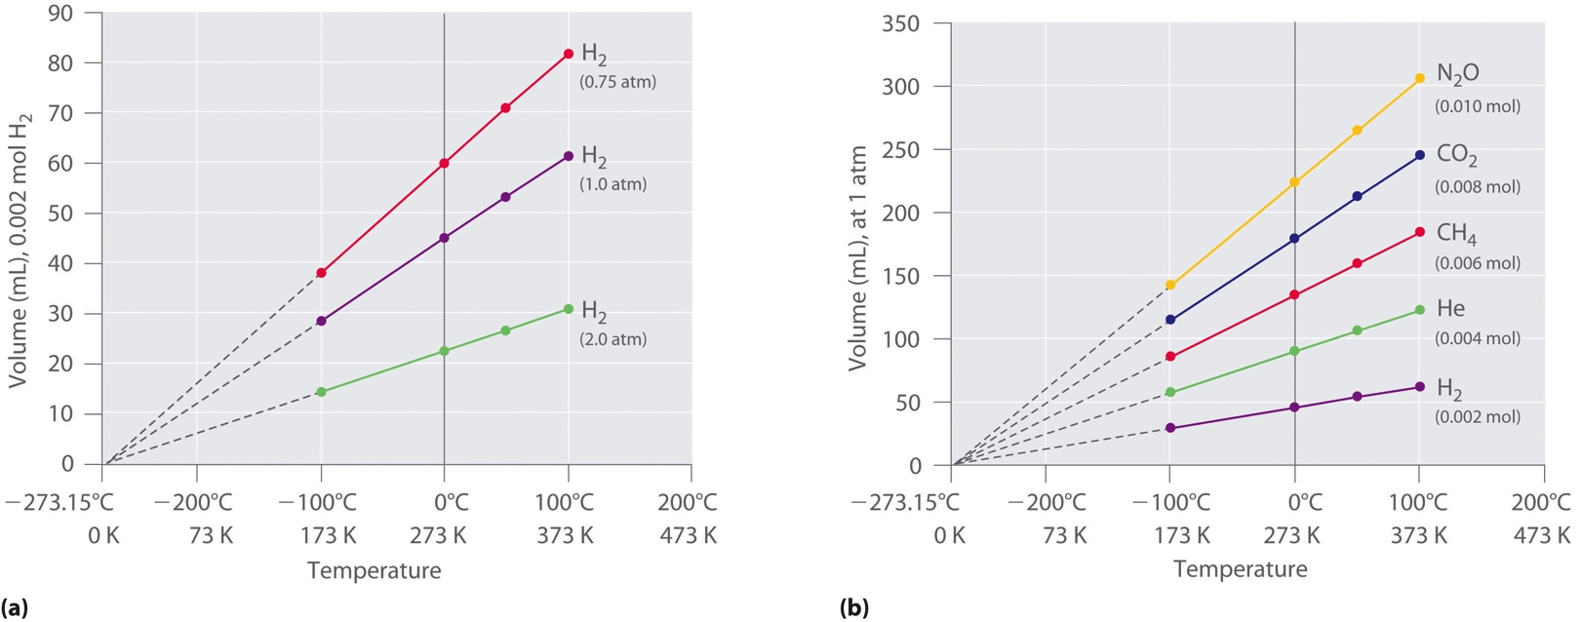
  - As the temperature is increased, its volume increases, assuming the pressure on the gas is constant.

  - The temperature at which a gas occupies a volume of zero is –273.15⁰C, absolute zero.
  - The Kelvin scale of temperature; the absolute scale, 0 K is equal to –273.15 ⁰C.
K = ⁰C + 273.15
or ⁰C = K - 273.15
e.g: A temperature of 25⁰C = 298.15 K
or A temperature of 136 K = -137.15 ⁰C
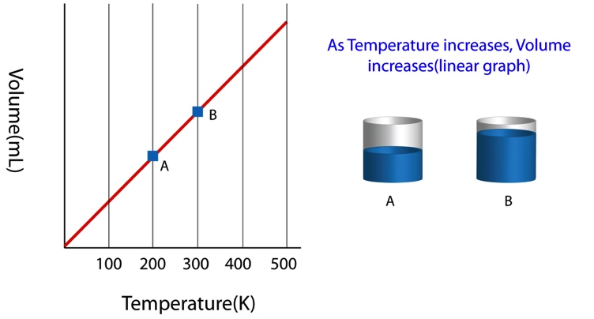

  - Charles’s Law:
At constant pressure, the volume of a given mass of gas is directly proportional to its temperature on the Kelvin scale.
  - This law can be expressed mathematically as:

where: V₁ = initial volume
T₁ = initial temperature in Kelvin
V₂ = final volume
T₂ = final temperature in Kelvin

  - The Kelvin temperature scale must be used when dealing with gas laws.
  - A rise in temperature causes an:
  - increase in the speed of the gas molecules,
  - thus their kinetic energy increases,
  - the molecules collide with the walls of the container more often and with greater force.

Example:
58.6 mL of air is collected at 35.6 ⁰C. The temperature is then increased to 85.2 ⁰C while the pressure is kept constant. What volume does the air occupy?

V₁ = 58.6 mL V₁ = V₂
T₁ T₂
T₁ = 308.75 K 58.6 = V₂ .
308.75 358.35
T₂ = 358.35 K V₂ = 58.6 x 358.35
308.75
V₂ = ? = 68.0 mL

NC 8.3 p351-2

Constant Volume Law
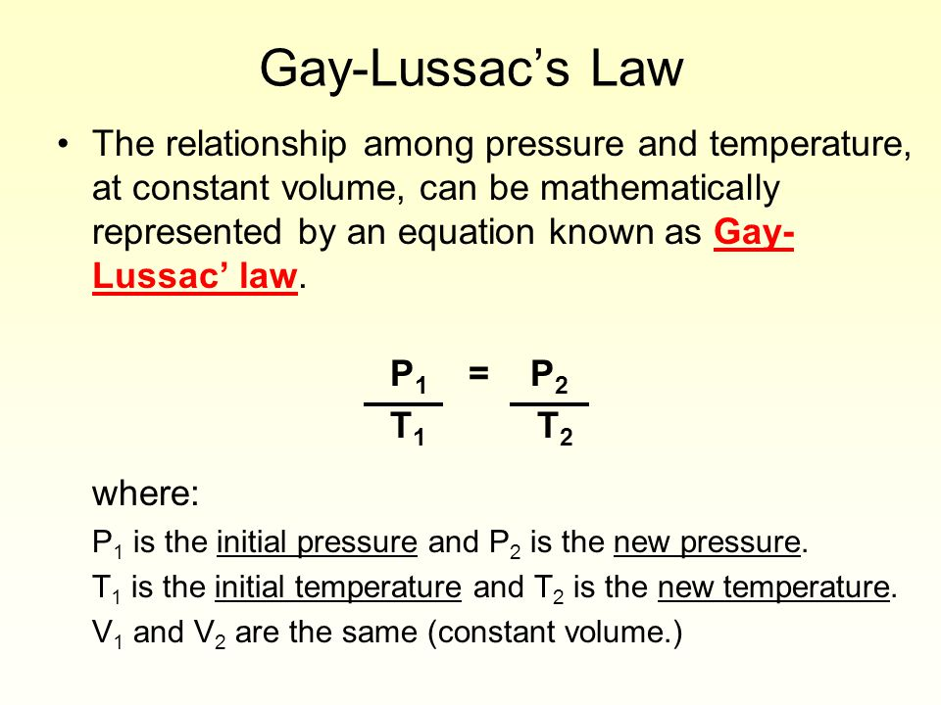
  - When the volume of a gas is held constant, the pressure is proportional to the absolute temperature.
where: P₁ = initial pressure P₂ = final pressure
P₁ = P₂
T₁ T₂

V₁ = initial temperature V₂ = final temperature

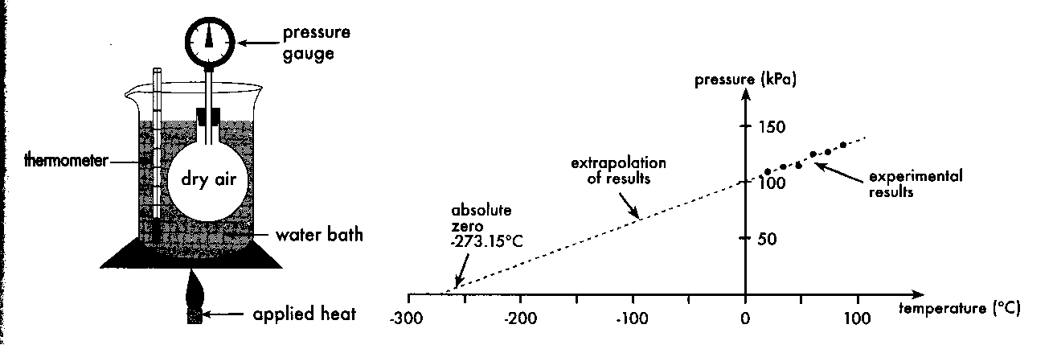

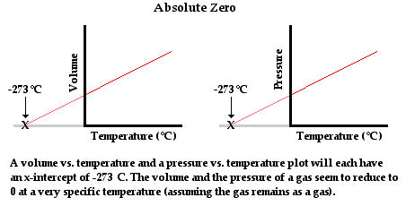
Combined Gas Law
- Boyle’s Law, Charles’s Law and the constant volume Law can be combined to form a general gas law
relating to P, V and T.

Example:
A gas with a volume of 225.5 mL and pressure of 123 kPa is at a temperature of 24 ⁰C. What temperature is needed to compress it to 100 mL at a pressure of 200 kPa?

V₁ = 0.2255 L P₁V₁ = P₂V₂
P₁ = 123 kPa T₁ T₂
T₁ = 297.15 K 123 x 0.2255 = 200 x 0.100
297.15 T₂
T₂ = ? T₂ = 200 x 0.100 x 297.15
P₂ = 200 kPa 123 x 0.2255
V₂ = 0.100 L = 214.2664 K
= 214 K

Questions:
- If the pressure of a sample of gas was to double and the temperature was halved, what would the new volume be?

- If the volume of a sample of gas was decreased to a quarter of the original volume and the pressure was doubled what would the new temperature be?

NC 8.3 p353 QS 8.3 p354
Observable properties, including vapour pressure, melting point, boiling point and solubility, can be explained by considering the nature and strength of intermolecular forces within a covalent molecular substance.

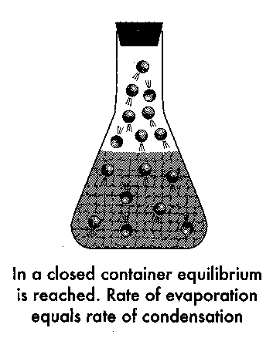
Vapour Pressure
- When water particles are placed in a closed container:
- Evaporation occurs.
- As the number of gaseous water molecules increases, and because they cannot escape, the frequencies of molecular collisions with the walls of the container, neighbouring water and gaseous molecules, increases.
- Some molecules will return to the liquid state upon colliding with the surface of the water.
- Eventually the rate of water molecules leaving the surface will equal rate of water molecules entering the liquid – a dynamic equilibrium exists.
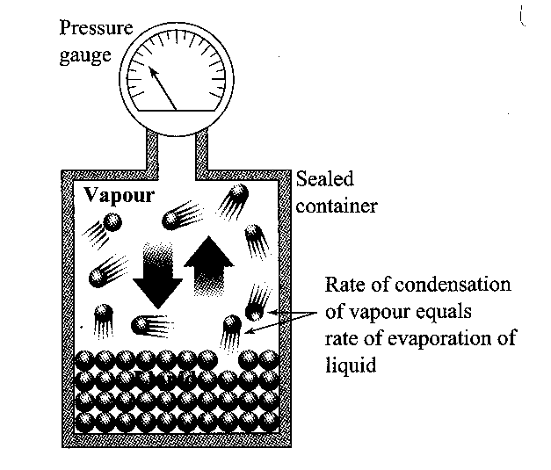
- Vapour pressure: water molecules exert a pressure due to their collisions with the walls of the container – vapour pressure.
- Different liquids have different vapour pressures since they have different intermolecular forces between particles.
- Vapour pressure increases at higher temperature as a greater proportion of particles have sufficient energy to enter the gaseous state.
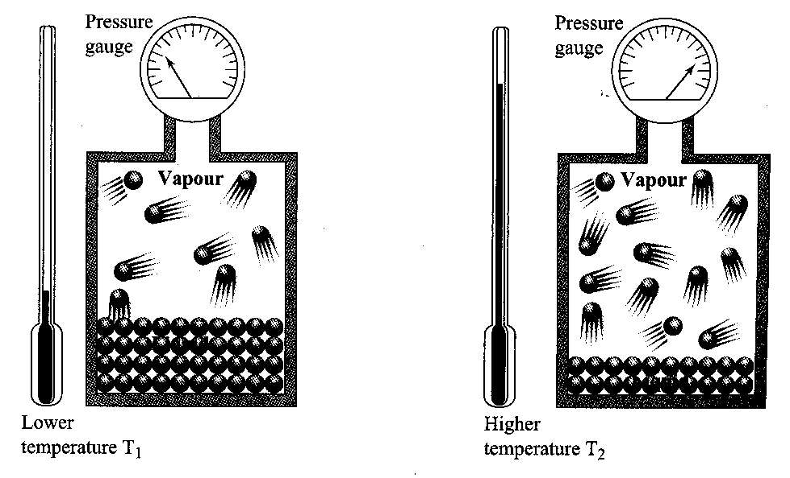

Vapour pressure and intermolecular forces

- For something to vaporise, you have to get enough energy together to break the interactions due to intermolecular forces. As a result, you'll need more energy (due to higher temperature) to break apart stronger intermolecular forces.

- Since higher vapor pressures corresponds to more gas in equilibrium, the intermolecular forces are therefore primarily weaker for higher vapor pressures.

- The stronger the intermolecular forces, the stronger the interactions that hold the substance together, the lower the vapor pressure of a liquid at the given temperature, and the harder it is to vaporize a substance.

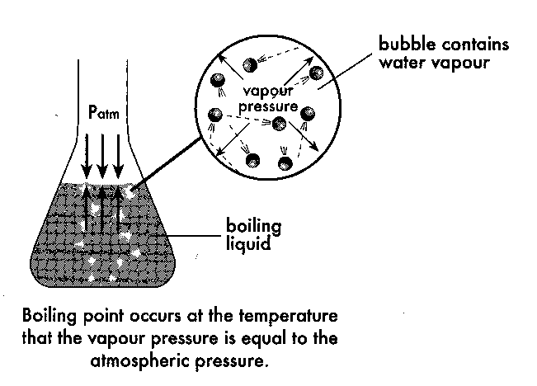
Boiling
- Water boils at 100 ⁰C. At this temperature the vapour pressure of the water equals the atmospheric pressure.
- Bubbles are formed when boiling occurs by:
- Vapour forms throughout the liquid.
- Vapour produced in the body of the liquid forms bubbles.
- As vapour pressure within the bubbles rise they become bigger and rise to the surface.
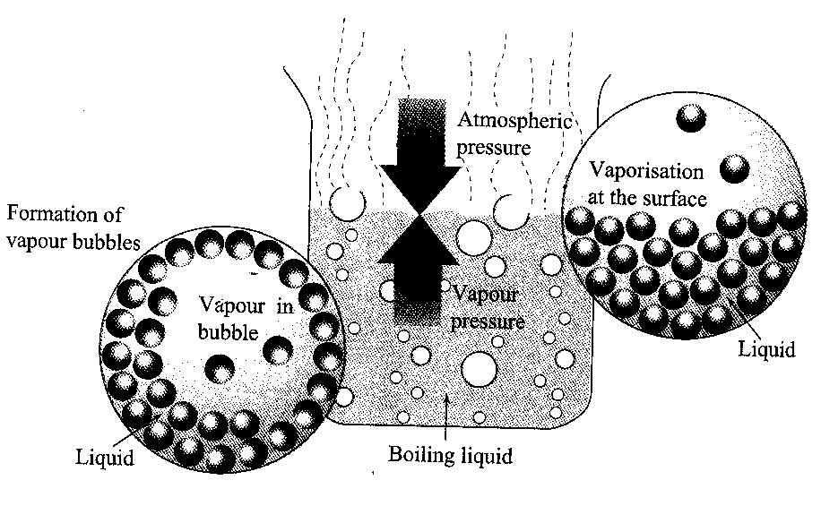
- Possible to predict the boiling points of different liquids by identifying the temperature at which vapour pressures and atmospheric pressures equal.
- Changing the atmospheric pressure can change boiling points:
- The lower the atmospheric pressure, the lower the boiling point.
- The higher the atmospheric pressure, the higher the boiling point.

Boiling point and intermolecular forces

- Since melting or boiling result from a progressive weakening of the attractive forces between the covalent molecules, the stronger the intermolecular force is, the more energy is required to melt the solid or boil the liquid.

- If only dispersion forces are present, then the more electrons the molecule has (and consequently the more mass it has) the stronger the dispersion forces will be, so the higher the melting and boiling points will be.

- As the mass of the molecules increases, so does the strength of the dispersion force acting between the molecules, so more energy is required to weaken the attraction between the molecules resulting in higher boiling points.

- If a covalent molecule has a permanent net dipole then the force of attraction between these molecules will be stronger than if only dispersion forces were present between the molecules. As a consequence, this substance will have a higher melting or boiling point than similar molecules that are non-polar in nature.

- Hydrogen bonding forces are the strongest of the intermolecular forces and covalent molecules than display hydrogen bonding forces have considerably higher melting points and boiling points to similar molecules that do not have hydrogen bonding forces.

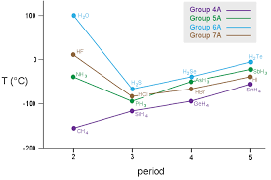

- Consider the hydrides of Group 4 elements. As the size of the molecule increases, dispersion forces become stronger due to larger molecules having more protons and electrons to attract other molecules. Stronger dispersion forces create higher boiling points, as more energy (higher temperature) is required to separate the molecules.

- However, the trend is not followed with Group 5, 6 and 7 hydrides. H₂O, HF and NH₃ should have lower boiling points if only dispersion forces and dipole-dipole forces are considered. These molecules have hydrogen bonding forces that are very strong and create the higher melting and boiling points.
EC 15.8 p131-2
Draw heating curves and explain the energy changes in each region of the curve

Heating Curves
- If heat is applied to a substance, there is an increase in its temperature and an increase in the average kinetic energy of its particles as temperature is a measure of the average kinetic energy of particles.
- At a particular temperature, there is no change in temperature – the heat applied causes a change of state. The applied heat is absorbed by the particles as potential energy – changing position of particles to each other (moving further apart).

- Consider the heating of ice until it melts then boils away.
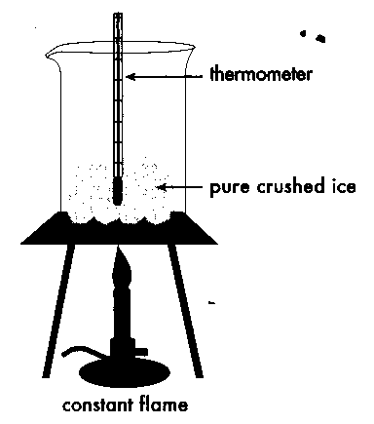

PROBLEM SET 5:
- Using the graph above, complete the following table:
Section | Phase or phases present | Increase in temp? | Increase in Potential Energy? | Increase in Kinetic Energy?
A – B
B – C
C – D
D – E
E - F

- Why are sections BC and DE horizontal? __________________________________________________________________________
__________________________________________________________________________
__________________________________________________________________________
- Why is section DE longer than section BC? __________________________________________________________________________
__________________________________________________________________________
__________________________________________________________________________
- Sulfur is cooled under controlled conditions from 500⁰C to room temperature (25⁰C). The melting and boiling points for sulfur are 113⁰C and 445⁰C respectively. Draw a cooling curve for sulfur and label the diagram to show the phase changes.

In which parts of the graph is sulfur losing heat to its surroundings? _________________
EC 1.6 p4
The mole concept can be used to calculate the mass of substances and volume of gases (at standard temperature and pressure) involved in a chemical reaction.
Avogadro’s Hypothesis And Molar Volume:

Avogadro’s Hypothesis
- The volume occupied by a gas depends on:
- temperature,
- pressure,
- the amount of gas which is present.

Avogadro’s hypothesis:
Equal volumes of any gas, measured at the same temperature and pressure, contain the same numbers of particles (moles).

2.0 L of hydrogen gas must have the same number of molecules as 2.0 L of oxygen gas.
2.0 L of hydrogen gas has a greater number of molecules than 1.0 L of oxygen gas.
Molar Volume
- The mole is the amount of substance containing 6.022 x 10²³ particles.
- One mole of any gas, occupies the same volume under the same conditions of temperature and pressure (STP).
- Molar volume – the volume occupied by one mole of any gas. At room temperature, molar volume of any gas is approximately 24 L.
- The molar volume of any gas at STP is 22.71 L

where: n = number of moles of gas (mol)
V = volume of gas in litres (L) at STP

- To find the number of moles with use the relationship:

where: m = mass of the sample (g)
M = mass of one mole of the substance (or molecular or formula mass) (g mol⁻¹)
Question 1:
What volume is occupied by 0.250 mol of hydrogen gas at STP?

Question 2:
What volume is occupied by 20.01 g of CO₂ _{(g)} at STP?

NC 8.4 p355-7
EC 10.6 p81-2
PROBLEM SET:
- Given a 2.50 L sample of hydrogen gas at STP, calculate:
  - The number of moles of hydrogen gas.

  - The mass of hydrogen gas.

- What volume will 48.0 g of oxygen gas occupy at STP?

Ideal gas equation.

General Gas Equations (working at non STP conditions)
- The molar volume relationship and the combined gas law can be combined to produce the general gas equation:

PV = nRT where: P = pressure of the gas (kPa)
V = volume of the gas in litres (L)
n = moles of gas (mol)
T = temperature of the gas (K)
R = gas constant – 8.314 J K⁻¹ mol⁻¹

- Temperature and pressure must be in correct units of kelvin (K) and kilopascal (kPa)
- Converting pressure to kilopascals:
Pressure can be in atmospheres (atm) or millimetres of mercury (mm Hg)
P (kPa) = P (atm) x 101.3
Example:
Neon gas in a 250 mL container has a pressure of 125.5 kPa at a temperature of 24.6 ⁰C. Calculate the mass of the neon inside the balloon.

V = 0.250 L PV = nRT
P = 125.5 kPa 125.5 x 0.250 = n x 8.315 x 297.75
T = 297.75 K n = 125.5 x 0.250
m = ? 8.315 x 297.75
n = 0.0127 mol

m(Ne) = n x M
= 0.0127 x 20.18
= 0.256 g

Crash Course Chemistry #13 https://www.youtube.com/watch?v=8SRAkXMu3d0
NC 8.4 p357-60 QS 8.4 p360
Question 1:
In an investigation into the chemical properties of an unknown metal, Peter adds 2.50 g of the metal to excess hydrochloric acid and collects the hydrogen gas liberated from the reaction. How many moles of hydrogen gas are formed if 15.0 mL of it are collected at 766 mm Hg and 23.0 ⁰C?

Example #2
Excess hydrochloric acid (HCl) reacts with a small amount of aluminium foil (Al) forming 3.98 L of hydrogen gas (H₂) measured at 18.0 ⁰C and 103.5 kPa. What mass of aluminium was used in the reaction?

Example #3
Excess aluminium foil is added to a solution containing 5.22 g of hydrochloric acid (HCl). What volume of hydrogen gas can be expected to form when the gas is measured at 155 kPa and 32.0 ⁰C?

Calculating Gases in Chemical Reactions.
Volume-volume relationships (at STP):
The steps in working out simple volume to volume calculations is as follows:
- Write a balanced equation and identify your known and unknown.
- Calculate the number of moles of the known using .
- Use the mole ratio to determine the number of moles of the unknown.
- Calculate the volume of unknown using V = n x 22.71.

Example Volume to Volume Calculation

In the production of ammonia gas, hydrogen gas and nitrogen gas are combined. If I have 85.12 L of hydrogen and excess nitrogen, how many litres of ammonia gas can you produce at STP?

Balanced equation. N₂ + 3H₂ 2NH₃
85.12 L ? L
Calculate n(H₂)
Mole ratio
Volume of unknown V(NH₃) = 2.499 x 22.71 = 56.8 L ammonia gas produced

Example for you to try:
In the production of water vapour, oxygen gas is combined with hydrogen gas
- Write the balanced equation

- If I have 58.24 L of oxygen gas, how many litres of hydrogen gas do I need?

Mass-Volume and Volume-Mass Relationships in Chemical Reactions
The steps in working out simple mass to volume or volume to mass calculations is as follows:
- Write a balanced equation and identify your known and unknown.
- Calculate the number of moles of the known using .
- Use the mole ratio to determine the number of moles of the unknown.
- Calculate the volume or mass of unknown using V = n x 22.71 or m = n x M.

Example of Mass to Volume at STP Calculation

What is the volume of carbon dioxide produced at S.T.P. when 12.4 g of copper II carbonate is heated strongly.

Balanced equation. CuCO_{3(s)} → CuO_{(s)} + CO_{2(g)}
12.4g ? L
Calculate n(CuCO₃)
Mole ratio
Volume of unknown V(CO₂) = 0.10003 x 22.71 = 2.28 L

Example of Mass to Volume (not at STP) Calculation

What is the volume of oxygen gas at 25.5 °C and 123.4 kPa required to react with 543 g iron to produce Fe₂O₃.

Balanced equation. 4Fe_{(s)} + 3O₂ → 2Fe₂O_{3 (s)}
543g ? L
Calculate n(Fe)
Mole ratio
Volume of unknown

Example of Volume to Mass Calculation
In the production of ammonia gas, 85 000 L of ammonia gas is produced. What mass (in kilograms) of nitrogen gas would be required to produce this amount of ammonia if you have excess hydrogen gas.

Balanced equation. N₂ + 3H₂ 2NH₃
? g 85 000 L
Calculate n(NH₃)
Mole ratio
Mass of unknown m(N₂) = 1871.4 x 28.02 = 52 437 g = 52.4 kg

NC 8.5 p361-2 Chap Review p364-6
EC 11.4, 11.5 p87-8
Example for you to try:
Consider the following reaction: 2C₄H_{10 (g)} + 13O_{2 (g)} → 8CO_{2 (g)} + 10H₂O _{(g)}
a. What volume of butane gas is needed to react with 204.8 g of oxygen gas?

b. What mass of carbon dioxide gas would be produced if you had 14.56 L of butane gas?

Example
What volume of hydrogen gas would be produced at S.T.P. by reacting 50.0 g of aluminium with hydrochloric acid?

2Al _{(s)} + 6HCl _{(aq)} → 2AlCl₃ _{(aq)} + 3H_{2 (g)}

Example
a. What volume of hydrogen will combine with 6.0 L of nitrogen to form ammonia?
b. What volume of ammonia would be produced assuming the reaction goes to completion?

N_{2 (g)} + 3H_{2 (g)} → 2NH_{3 (g)}

PROBLEM SET :

- The reaction between hydrogen sulfide and sodium hydroxide is given by the following equation:
2NaOH _{(aq)} + H₂S _{(g)} → Na₂S _{(aq)} + 2H₂O _{(l)}
Sodium hydroxide is dissolved in water and 1.8500 L of hydrogen sulfide gas at STP is bubbled through the solution. Determine the following:
- The moles of hydrogen sulfide gas.

- The mass of NaOH that reacted with the hydrogen sulfide gas.

- Ammonia can be oxidised according to the following equation.
4NH₃ _{(g)} + 5O₂ _{(g)} → 4NO _{(g)} + 6H₂O _{(g)}
Given that 58.4 g of oxygen gas are required to react with the ammonia gas, find the volume of
nitrogen oxide gas produced at 28 °C and 187.6 kPa .

- If 261.54 g of butane is burnt in oxygen, calculate:
- the number of moles of butane gas.

- the number moles of oxygen gas which would be required to react completely with it.

- the mass of water produced.

d. the volume of carbon dioxide gas produced at STP.

- The equation for the production of glucose by photosynthesis is:

6CO_{2 (g)} + 6H₂O_{(l)} → C₆H₁₂O_{6 (s)} + 6O_{2 (g)}
Calculate the mass of carbon dioxide gas required to produce 3.61 g glucose.

- What mass of Aluminium would be used to produce 1546.7 mL of hydrogen gas at 10 °C and 194.6 kPa?

2Al _{(s)} + 6HCl _{(aq)} → 2AlCl₃ _{(aq)} + 3H_{2 (g)}

How Much Do You Know. Answers at back

- Graph the data in the table below:

Temp. (⁰C) | 0 | 20 | 40 | 60 | 80 | 100
Volume (mL) | 3.50 | 3.76 | 4.00 | 4.27 | 4.52 | 4.78

- Graph the data on the graph below.

- Which gas law does the table relate to?

- Extrapolate the graph to a volume of zero. What temperature is indicated?

- What is the significance of this temperature?

- What is the relationship between temperature and volume?

- Graph the results below onto the graph shown.
Graph the results below onto the graph shown.
Pressure (kPa) | 100 | 200 | 300 | 400 | 500 | 600
Volume (L) | 4.00 | 2.00 | 1.33 | 1.00 | 0.80 | 0.67

- Which gas law does the graph relate to?

- What relationship exists between Pressure and Volume?

- What does STP stand for?

- Why do volumes of gases need to be compared at STP?

SUMMARY

- Kinetic Theory of gases explains the physical properties of gases.
  - Gases are composed of tiny particles.
  - The particles are relatively widely spaced
  - The particles move rapidly.
  - The forces of attraction between the particles are negligible.
  - Collisions between the particles are perfectly elastic.
  - The average kinetic energy of the particles increases with temperature.
- Boyle’s Law – for a gas at constant temperature, if the volume increases the pressure increases (and vice versa).
- Charles’ Law - for a gas at constant pressure, if the temperature increases the volume increases (and vice versa).
- Constant Volume Law - for a gas at constant volume, if the temperature increases the pressure increases (and vice versa).
- Kelvin temperature (K) = Celsius temperature (°C) + 273.15
- Standard Temperature and Pressure (STP) are 273.15 K (0 °C) and 100 kPa.
- Potential energy of particles is due to position.
  - In a gas, particles have greater potential energy than in a liquid.
  - In a liquid, particles have greater potential energy than in a solid.
- Kinetic energy of particles is due to motion
- The average kinetic energy of particles increases with temperature.

How Much Do You Know.

- Graph the data on the graph below.

- Charles’s Law
- -273.15⁰C
- Known as absolute zero or 0 K.
- As temperature increases so does volume – they are directly proportional.

- Boyle’s Law
- As volume increases, pressure decreases so inversely proportional

What does STP stand for? Standard Temperature and Pressure

Why do volumes of gases need to be compared at STP?

When comparing volumes of gases they must be at the same temperature and the same pressure to make the comparison fair. If they are compared at different temperatures, the gas with the higher temperature will have a higher volume and if they are compared at different pressures, the gas with the lower pressure will have a higher volume.

